# ELEC 425 – Assignment 2

## 1 – Implement K-medians

### 2 clusters

#### Cluster centres = [5.5, 4; 4.5, 3.2]

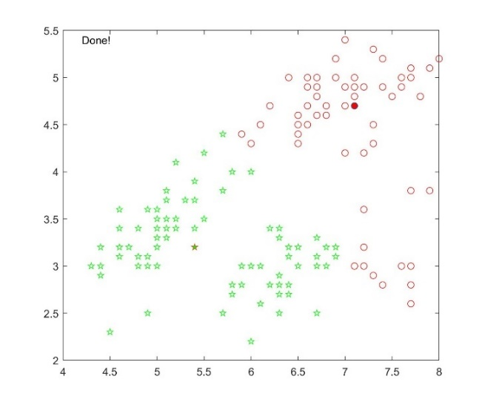

#### Cluster centres = [3.1, 5.2; 3.8, 4.2;]

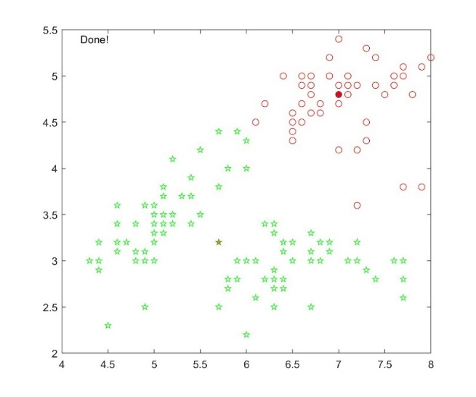

#### Cluster centres = [3, 3; 6, 6]

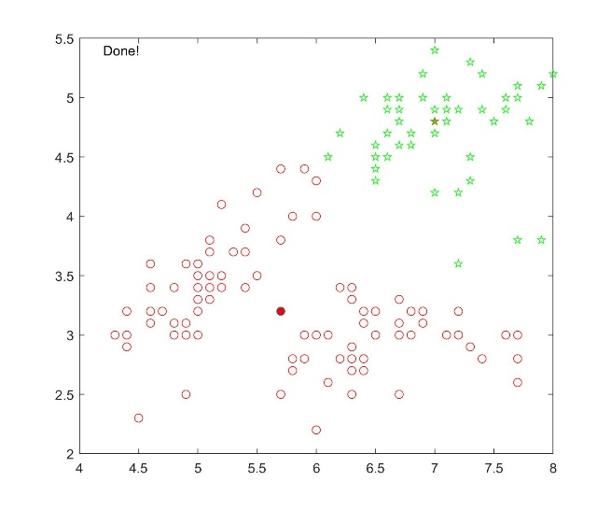

### 3 clusters

#### Cluster centres = [3, 3; 4, 4; 6, 6]

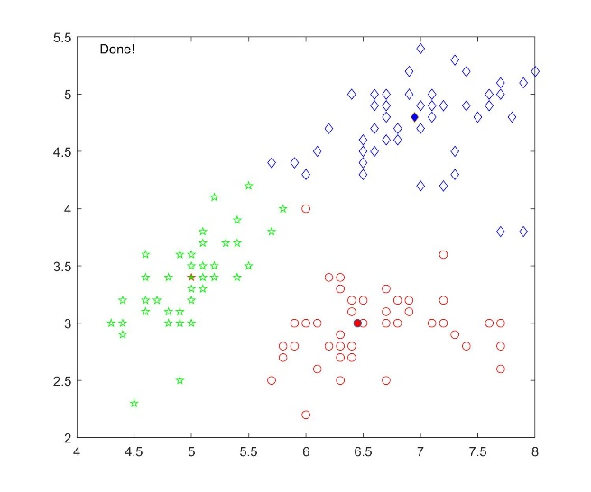

#### Cluster centres = [3.5, 4.3; 3.9, 5.6; 3.4, 3.8]

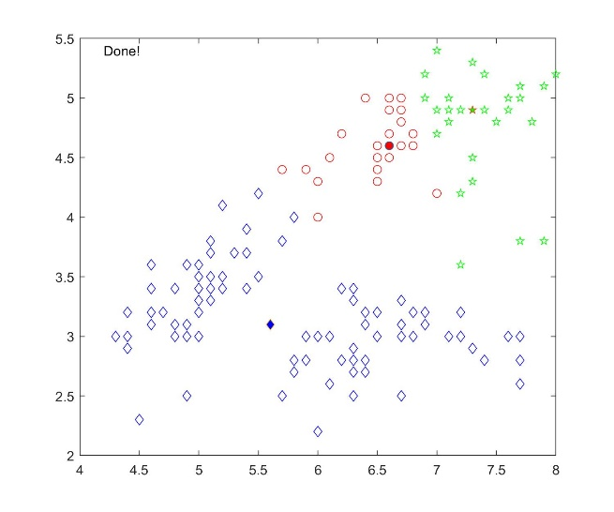

### *Cluster centres = [4, 5; 4.8, 5.2; 3.9, 6]*

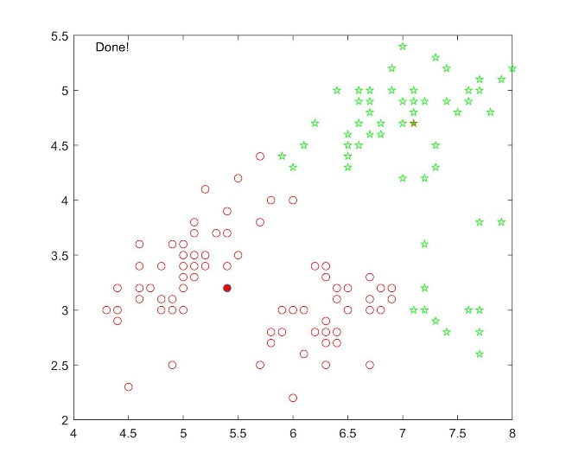

### 4 clusters

#### Cluster centres = [3, 3; 4, 4; 5, 5; 6, 6]

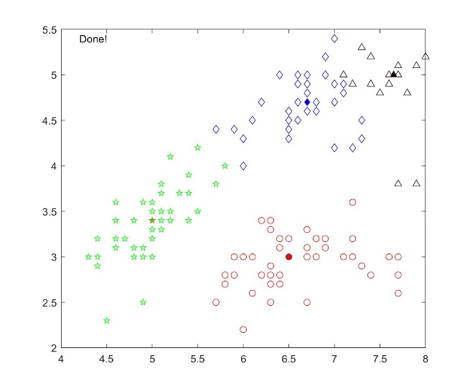

#### Cluster centres = [6, 4; 4, 3; 5, 4; 6, 5]

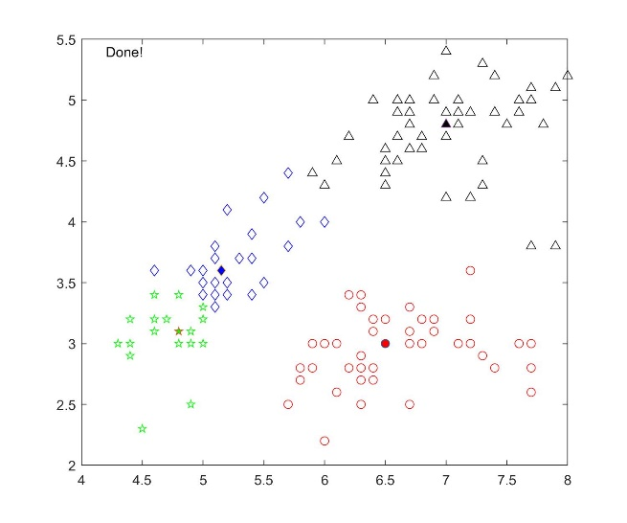

#### Cluster centres = [4, 5; 8, 3; 7.6, 5; 8, 3.5]

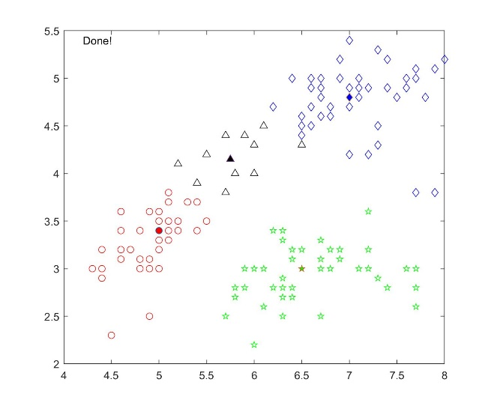

The relevant code can be found in *k_medians.m* (code was too large to include in this document).

## 2 – Prove the EM Updating Algorithm Used in K-medians

Similar to the proof that K-means minimizes the following loss function:

$$J= \sum_{n=1}^{N}{\sum_{k=1}^{K}{r_{nk}{\left\|x_{n}-µ_{k}\right\|}^{2}}}$$

The K-median algorithm minimizes the following loss function: $$J= \sum_{n=1}^{N}{\sum_{k=1}^{K}{r_{nk}\left|x_{n}-µ_{k}\right|}}$$

The terms involving *n* are independent, so each *n* can be optimized for separately by choosing *rnk* to be 1 for whichever value of *k* gives the minimum value of *|xn – µj|:*

To optimize *µk* with *rnk* fixed, take the derivative with respect to *uk* and set it to 0:

$$\frac{dJ}{dµ_{k}}=\sum_{n=1}^{N}{\sum_{k=1}^{K}{r_{nk}*sign\left[{µ_{k}-x}_{n}\right]}}$$

$$0=\sum_{n=1}^{N}{\sum_{k=1}^{K}{r_{nk}*sign\left[{µ_{k}-x}_{n}\right]}}$$

$$=\left(\#x_{n} smaller than µ_{k}\right)-(\#x_{n} bigger than µ_{k})$$

$$û_{k}=median[x_{1}, … , x_{n}]$$

Thus, we can see that to optimize the K-median loss function, we reach the conclusion that setting *µk* to the median of all points assigned to cluster *k* optimizes this loss function. Therefore, it is proven that the K-medians algorithm minimizes that error function.

## 3 - K-medoids

### 2 clusters

#### Cluster Centres = [5.9, 3.0; 7.1, 4.8]

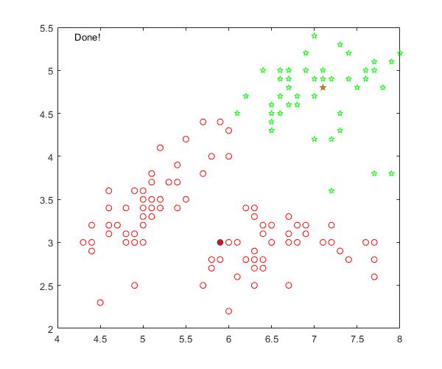

#### Cluster Centres = [7.1, 4.8; 5.9, 3.0]

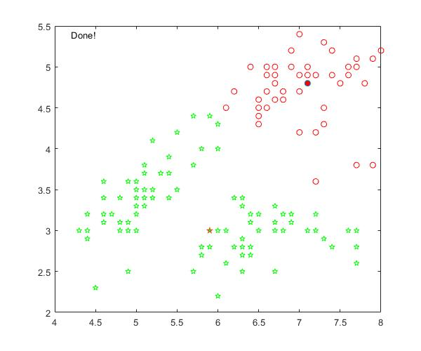

#### Cluster Centres = [5.4, 3.4; 7.0, 4.7]

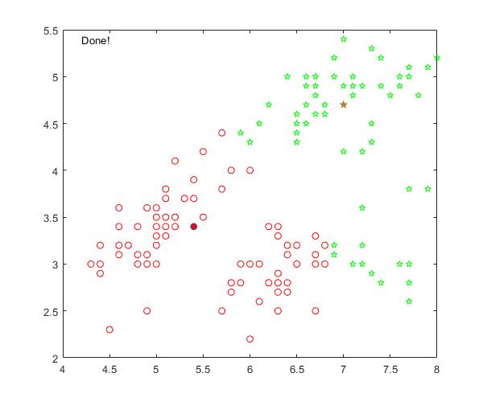

### 3 clusters

#### Cluster Centres = [6.5, 3.0; 7.0, 4.9; 5.0, 3.4]

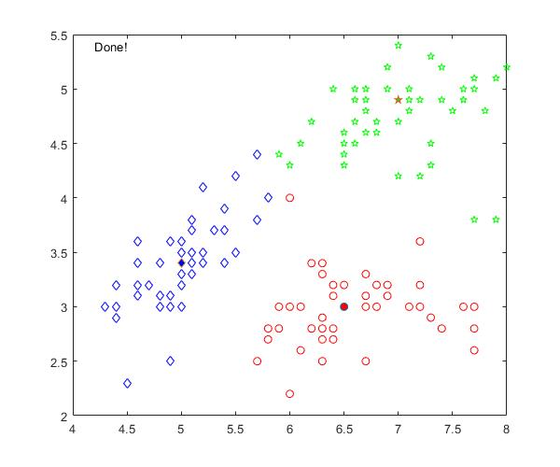

#### Cluster Centres = [6.5, 3.0; 5.0, 3.4; 7.0, 4.9]

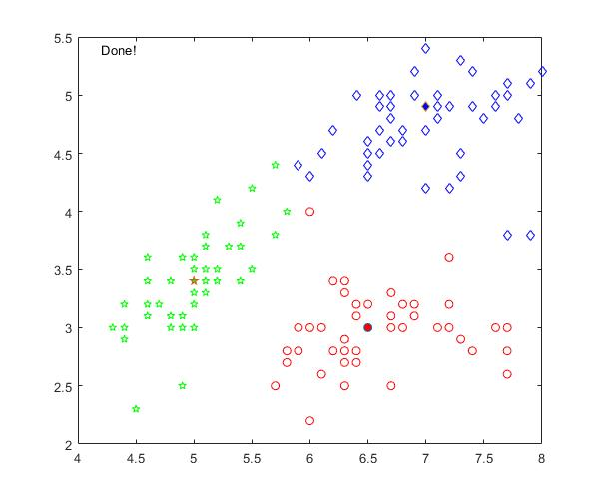

#### Cluster Centres = [7.0, 4.9; 5.0, 3.4; 6.5, 3.0]

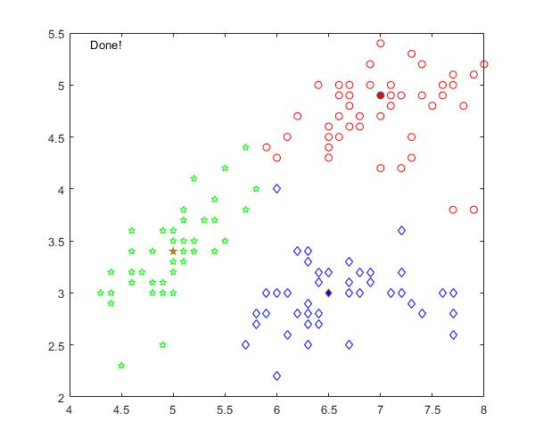

### 4 clusters

#### Cluster Centres = [7.0, 4.9; 5.9, 3.0; 7.7, 5.0; 6.5, 4.4]

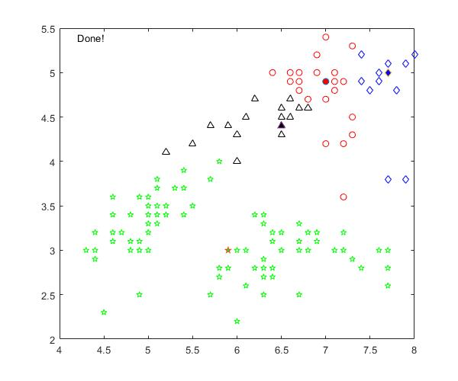

#### Cluster Centres = [5.4, 3.9; 6.5, 3.0; 4.8, 3.1; 7.0, 4.9]

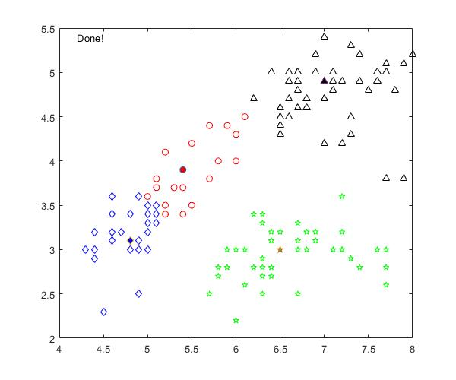

#### Cluster Centres = [5.0, 3.4; 6.3, 2.8; 7.2, 3.0; 7.0, 4.9]

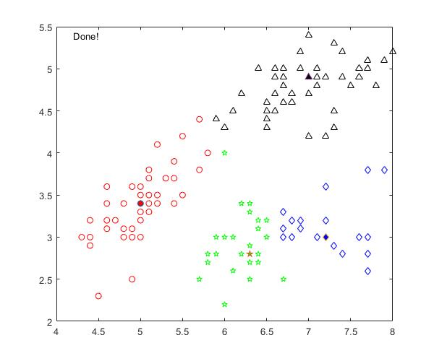

The relevant code can be found in *k_medoids.m* (code was too large to include in this document).